# Create a Milestone Template Procedure

Service Level Management

**Purpose**

Milestones are notification mechanisms to ensure that Service Targets are being met. Actions are used in conjunction with Milestones to notify personnel when a Monthly SLA is in danger of being breached and / or has been breached. SLM uses Milestone templates for multiple Service Targets to ensure that notifications are consistent regardless of the Service or Service Level Tier.

***Note:*** *For customized Milestones, see the* [Create a New Service Target for a Platinum Application](https://confluence.jacksonnational.com/display/CPENABLE/Create+a+New+Service+Target+for+Platinum+Application) procedure*.*

**Related Policy**

* [IT Service Management Policy](https://sharepoint.jackson.com/sites/itsmsd/servicelevelmanagement/Shared%20Documents/Pre%20December%202019/SLM%20Documents/Policy%2C%20Process%2C%20Procedures/SLM_Service%20Level%20Management%20Process.doc?d=wa1eaba53e1dc4b30abda2a0886981cc9)

**Audience**

The following groups are responsible for adhering to this document:

* Service Level Management

**Procedure**

|  |  |
| --- | --- |
| Step | Action |
| 1 | Identify the compliance target percentage that is required for the Milestone template:   1. Review the Metric Data Definition (MDD) spreadsheet (see ***Appendix A***) to identify each application’s compliance target (the required percentage to meet the SLA). |
| 2 | Access the Templates section of Remedy to verify if a viable template already exists:   1. In the Remedy system, select the Applications tab on the side. 2. Select “Administrator Console”. 3. Select “Application Administration Console”.   cid:image001.png@01D32CA3.A8FED240   1. Click the “Custom Configuration” tab.      1. Click “Service Level Management” drop down-arrow. 2. Click “Configure Application Settings” drop down-arrow.      1. Click “Templates” from list.      1. This will bring up the “Configure Templates” screen. In the “Show Templates For” field, select “Milestone” from the drop-down list.      1. A list of Milestone templates will appear.      1. Click “Name” on the blue bar to put the templates in alphabetical order.      1. If the Milestone template you are looking for exists, you are done with this procedure.   See ***Appendix B*** for standard naming convention.   1. If the desired template does not exist, continue to Step 3. |
| 3 | **To Create a New Milestone Template:**   1. Click the “Create” button.      1. In the “Used By” field, select “CI-Outage” from the drop-down menu.     ***Note:*** *The “Applies To” field will auto populate.*   1. Click the “OK” button. 2. For this example, a Milestone is being created to send an alert when a 99% Service Target is at 90% in danger of being breached. Fill in the following fields:    * **Title**: Enter a name to best describe what the Milestone is.   See ***Appendix B*** for the standard naming convention.   * + **Description:** Copy and paste the “Title” name into this field.   + **Execute If:** Select “Available %” from the drop-down menu.   To calculate the “Execute If” percentage, use the formula in ***Appendix C***.  Enter the “Execute If” percentage in the “=” field.     1. Click the “OK” Button.   ***Note:*** *Milestone templates will be linked to Milestone Action templates during the creation of a Service Target.*  For more information see:  [Create a Milestone Action Template Procedure](https://confluence.jacksonnational.com/display/CPENABLE/Create+a+Milestone+Action+Template?preview=/610911005/610912797/Create%20a%20Milestone%20Action%20Template%20Procedure.docx)  [Create a New Service Target for a Platinum Application](https://confluence.jacksonnational.com/display/CPENABLE/Create+a+New+Service+Target+for+Platinum+Application) |

**Appendix A – Metric Data Definition Forms / Compliance Target**

Locate the correct [Metric Data Definition (MDD](https://sharepoint.jackson.com/sites/itsmsd/servicelevelmanagement/_layouts/15/start.aspx#/Shared%20Documents/Forms/AllItems.aspx?RootFolder=%2Fsites%2Fitsmsd%2Fservicelevelmanagement%2FShared%20Documents%2FPre%20December%202019%2FMDD%20Database%20Files&FolderCTID=0x012000C3EC5FEE7B19F646BACB9A57478C774E&View=%7B527EAB19%2D8D4A%2D47E6%2DACE1%2DCA631A3D99D0%7D)) spreadsheet in SharePoint.

***Note:*** *At this time only Service Targets for Platinum applications would have Milestones Templates applied to them, therefore the Metric Database CPI data spreadsheet should be used*.

1. Access the correct spreadsheet in which the application falls under.

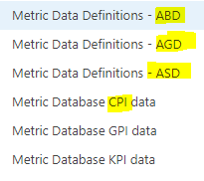

* + **ABD** – Aggregate Bronze Definitions
  + **AGD** – Aggregate Gold Definitions
  + **ASD** – Aggregate Silver Defintions
  + **Metric Database CPI Data** – Platinum definitions

1. Locate the application in the spreadsheet.
2. Review “Column F” (Compliance Minimum) on the specified application’s row.

In this example, 99.0100% is the minimum percentage in which the SLA can be met.

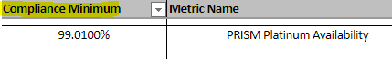

**Appendix B – Milestone Template Standard Naming Convention**

The Milestone template is named in the “Title” field.

Below are naming examples for percentage milestones and a breached milestone.

* + **Percentage Milestone**

AvailTarget at XX%_YY%ExpectedAvail

* XX = milestone percentage
* YY = compliance target percentage

Example:

AvailTarget at 90%_99%ExpectedAvail

* + **Breached Milestone**

Avail Target Breached_YY%ExpectedAvail

* YY = compliance target percentage

Example:

Avail Target Breached_99%ExpectedAvail

**Appendix C – Execute If* Percentage Calculation Formula**

The “Execute If*” percentage is the point in which the Milestone will trigger the Milestone Action linked within the Service Target. The Milestone is reached based on the “Available %” in the monthly Measurement Record.

For more information see:

[Measurement Record Documentation](https://confluence.jacksonnational.com/display/CPENABLE/01+-+SLM+Measurement+Record+Documentation?preview=/575465542/575465548/Measurement%20Record%20Documentation.docx)

In this example, for the action to be triggered, the percentage is 90% and the Compliance percentage is 99%.

Use this key to calculate formula.

* **Goal percentage** = The goal percentage will always be 100%
* **Compliance percentage** = The percentage required for the SLA to be met.
* **Action trigger percentage** = The Milestone percentage in which the action will be triggered.
* **Base number** = Goal percentage minus Compliance percentage
* **Resulting Available percentage** = Base number multiplied by Action percentage.
* **Execute If* percentage** = The percentage in which the Action

linked to the Milestone will be triggered.

**Formula Steps**

1. Goal percentage – Compliance percentage = Base number

Example: 100 – 99 = 1

1. Base number * Action trigger percentage = Resulting Available percentage

Example: 1 * .90 = .90

1. Goal percentage – Resulting Available percentage = Execute If* percentage

Example: 100 – .90 = 99.10

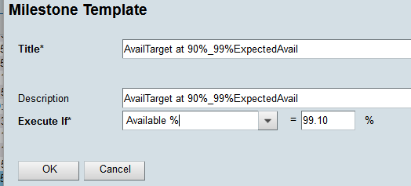

**Appendix D – Milestone Examples**

The following are examples of Milestone templates that have been created for a 99% compliance target percentage.

**50% of 99% Service Target example**

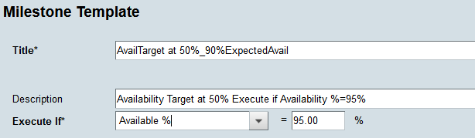

**75% of 99% Service Target example**

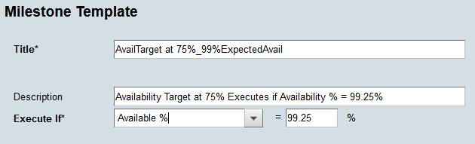

**90% of 99% Service Target example**

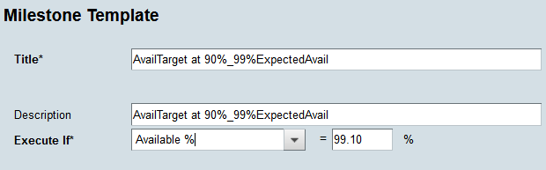

**Breached 99% Service Target example**

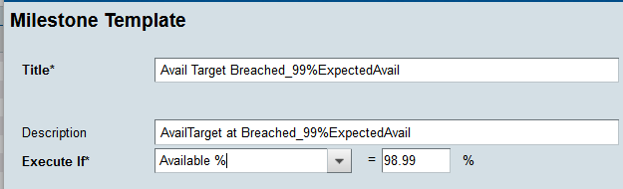

**Appendix E – Milestone & Associated Service Targets**

When a Milestone template is linked to a Milestone Action template within a Service Target, the associated Service Targets will appear in the bottom box on the “Configure Templates” screen. Click on the Milestone Action template in the top box to display the list of associated Service Targets.

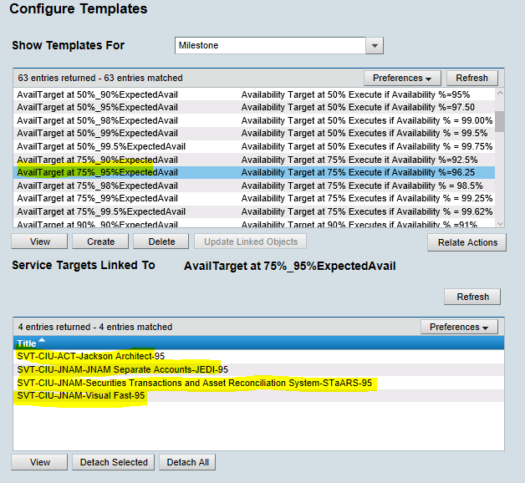

**Modification**

The following associates can make modifications to this document:

* Manager, Service Level Management
* Director, IT Service Management
* Vice President, Service Delivery
* Chief Technology Officer, PGDS

|  |  |
| --- | --- |
| Service Level Management Process | |
| Responsible Party: Sharla Piepkow, Manager, Service Level Management Approving Authority: Rob Kolm, Director, IT Service Management | Date Created: 08/08/2017 Last Modified: 05/13/2020 Last Reviewed: |